Redbridge  PATIENT PARTICIPATION GROUPS 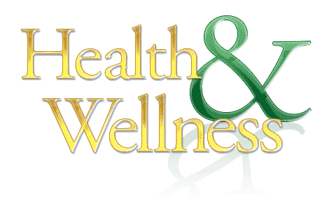  COMMUNITY HEALTH OPEN DAY  JUST DROP IN  THURSDAY 11TH OCTOBER 2018  1.30PM TO 5.00PM  Quick checks – Blood Pressure, Diabetes, ECG  - Lifeline - Dietician - Pharmacist - Hearing Loss - Age UK - Podiatrist - Care Service - Tai Chi - Healthwatch - Mental Health - Nurse-Practitioner - TB Awareness  SOUTH WOODFORD HEALTH CENTRE  114 HIGH ROAD, E18 2QS  (ENTRANCE FROM HIGH ROAD)  Further details from  Chandra Patel (Elmhurst 07961 145592, Rakesh Datta (Queen Mary) 07931 514129, Michelle Green (Shrubberies) 0208 505 8354 | Redbridge  PATIENT PARTICIPATION GROUPS  COMMUNITY HEALTH OPEN DAY  JUST DROP IN  THURSDAY 11TH OCTOBER 2018  1.30PM TO 5.00PM  Quick checks – Blood Pressure, Diabetes, ECG  - Lifeline - Dietician - Pharmacist - Hearing Loss - Age UK - Podiatrist - Care Service - Tai Chi - Healthwatch - Mental Health - Nurse-Practitioner - TB Awareness  SOUTH WOODFORD HEALTH CENTRE  114 HIGH ROAD, E18 2QS  (ENTRANCE FROM HIGH ROAD)  Further details from  Chandra Patel (Elmhurst 07961 145592, Rakesh Datta (Queen Mary)  07931 514129, Michelle Green (Shrubberies) 0208 505 8354

